

Auto-Zero Amplifiers

White Paper

Analog Devices, Inc.
1500 Space Park Drive
P.O. Box 58020
Santa Clara, CA 95052-8020
(408) 562-2775

Introduction

A wide variety of electronic applications, especially those involving very small input signals, require signal paths with very low offset voltage and offset voltage drift over time and temperature.
When standard linear components are used, the only way to achieve this low offset and drift is to use system level auto-calibration. However, adding auto-calibration requires more complicated and costly hardware and software and can slow down time-to-market for new products. The alternative is to use components with low offset and drift performance. The amplifiers with by far the lowest offset and drift available share a common design architecture—the “chopper” or auto-zero amplifier type. However, these amplifiers have been quite expensive compared to traditional precision amplifier designs.
Analog Devices’ new AD855x and AD857x amplifiers reach new performance levels for precision and accuracy at 5 V and below, at about half the cost of previous chopper-type designs. The reduction in cost, combined with the outstanding precision, enables truly precise and stable system designs without the previous cost penalty of auto-calibration or expensive components. The AD857x also introduces an exciting new, patented spread spectrum approach that eliminates the barriers to using auto-zero amplifiers over wide signal bandwidth.

Chopper Amplifiers

Chopper type amplifier topologies have existed for decades (Goldman et al, April 28, 1949 #2,684,999). Actual implementations — from tube types through silicon hybrids — have been around nearly as long. Initial chopper efforts actually involved switched AC coupling of the input signal and synchronous demodulation of the AC signal to re-establish the DC signal. While these amplifiers achieved very low offset, low offset drift, and very high gain, they had limited bandwidth and required filtering to remove the large ripple voltages generated by the chopping action.
Chopper-stabilized amplifiers solved the bandwidth limitations by combining the chopper amplifier (used as a stabilizing amplifier) with a conventional wideband amplifier that remained in the signal path. However, simple chopper stabilized designs are capable of inverting operation only since the stabilizing amplifier is connected to the non-inverting input of the wideband amplifier.
Virtually all modern IC chopper amplifiers actually use an auto-zero approach utilizing a two (or more) stage composite amplifier structure similar to the chopper-stabilized scheme. One stage provides nulling action, while the other provides wideband response. Together, the two stages provide very high voltage gain as they are connected in series.
In this approach, the inputs of the nulling stage are shorted together during the first phase of the operational cycle. During this nulling phase, amplified feedback is used to virtually eliminate the offset of the nulling stage. The feedback voltage is impressed on a storage capacitor so that during the second, or “output,” phase the offset remains nulled while the inputs are now connected to the signal of interest.
In the output phase, the nulled input stage and the wideband stage in series amplify the signal. The output of the nulled stage is impressed on a storage capacitor so that when the cycle returns to the nulling phase (inputs shorted together), the output continues to reflect the last input voltage value. Higher frequency signals bypass the nulling stage through feed-forward techniques, making wide bandwidth operation possible.
While this technique provides DC accuracy and better frequency response, along with the flexibility of inverting and non-inverting configurations, it is prone to high levels of digital switching “noise” that limit the usefulness of the wider bandwidth.

AD855x/AD857x improves on choppers

ADI’s AD855x and AD857x auto-zero amplifiers use a similar architecture with some major improvements. Dual nulling loops, special switching logic and innovative compensation techniques result in dynamic performance improvements while minimizing total die area. The result, amplifiers that retain the high gain and DC precision of the auto-zero approach while minimizing the negative effects of digital switching on the analog signal — at half the cost. Typical offset voltage is under 1 µV and the offset drift is less than 10 nV/ºC. Voltage gain is more than 10 million, while PSRR and CMRR are well above 120dB. Input voltage noise is only 1µV P-P from DC to 10 Hz.
Many auto-zero amplifiers are plagued by long overload recovery times due to the complicated settling behavior of the internal nulling loops after saturation of the outputs.
Analog Devices’ auto-zero amplifiers have been designed so that internal settling occurs within one or two clock cycles after output saturation occurs. The result is that the overload recovery time is more than an order of magnitude shorter than previous designs and is comparable to conventional amplifiers.
The careful design and layout of the AD855x amplifiers reduces digital clock noise and aliasing effects by as much as 40dB versus older designs.
The AD857x goes one step further in reducing the effects of digital switching on the analog signal. Using a patented digital spread-spectrum technique, the AD857x virtually eliminates the energy spike seen in other auto-zero amplifiers at the switching frequency and reduces aliasing products between the chopping clock and the input signal to the noise floor. The only penalty for this breakthrough performance is a slight increase in voltage noise from the industry-best 1 µV P-P from DC to 10 Hz. of the AD855x design.

Implementation

The actual circuit implementation of an IC auto-zero amplifier is much more complicated than the simplified version described above. In the Analog Devices design multiple nulling loops are combined with innovative compensation, signal paths are fully differential, amplifier sections consist of multiple stages and storage capacitors are Miller multiplied. Internal voltages must be controlled carefully to prevent saturation of the nulling circuitry. In addition, special logic characteristics are utilized and careful layout is required to minimize parasitic effects. These techniques result in stable, reliable operation and minimize unwanted digital interaction with the analog signals.
The frequency response of the nulling and wideband amplifiers is carefully tailored so that low frequency errors (DC circuit offsets and low frequency noise) are nulled while high frequency signals are amplified as in a conventional op amp. This nulling of low frequency errors has an important consequence for voltage noise. The very low frequency 1/f noise behavior seen in conventional amplifiers is not present in auto-zero amplifiers. For applications with long measurement times on slowly varying signals the noise performance is better than the best low noise conventional amplifier designs.
In this IC implementation, the size of the on-chip storage capacitors is limited to achieve a cost-effective die size. The small storage capacitors require careful attention to the switch design and layout so that charge injection effects do not create large offset errors. Switch leakage must also be minimized to maintain circuit accuracy, especially at high temperatures. In the AD855x and AD857x amplifiers, the switches have been optimized for accurate operation up to +125°C

Operation description

The following pages contain a more detailed description of the operation of the auto-zero amplifier function.
The simplified circuit (fig 1) consists of the nulling amplifier (A_{A}), the wideband amplifier (A_{B}), storage capacitors (C_{M1} and C_{M2}) and switches for the inputs and storage capacitors. There are two phases (A and B) per clock cycle.
In Phase A, the auto-zero phase, the nulling amplifier auto-zeros itself while the wideband amplifier amplifies the input signal directly. In phase B both amplifiers amplify the input signal.
Fig 1 Simplified circuit schematic
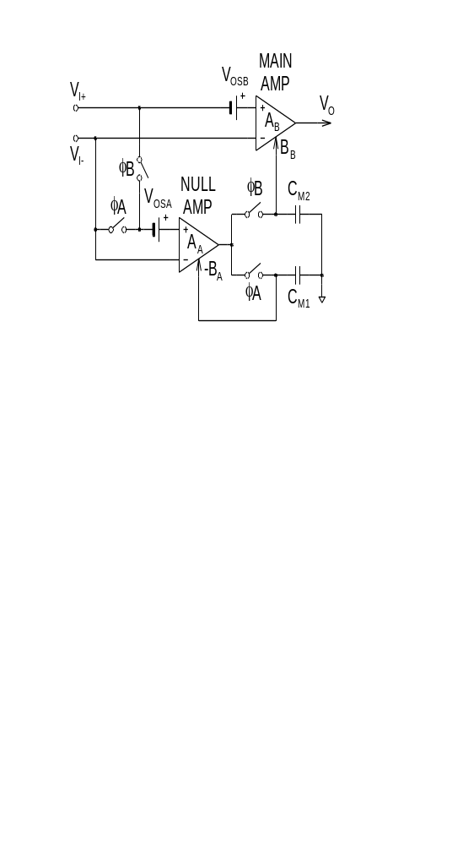

Using the trimmable op-amp model (fig 2)…

Fig 2 Trimmable op-amp model
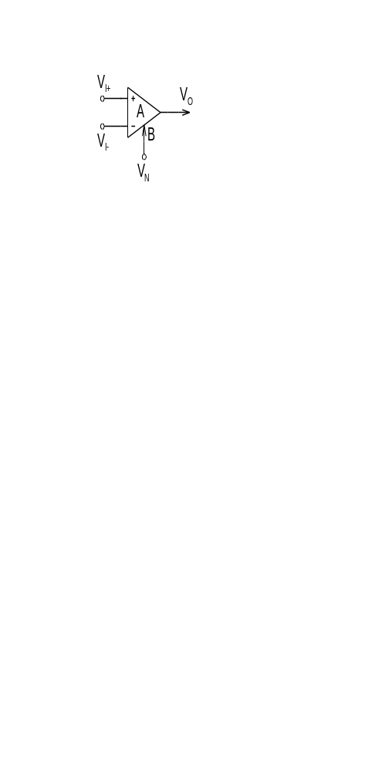 | 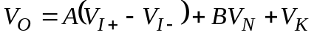  A = differential gain  B = trim gain  VK = offset voltage at output

Analysis begins with the nulling phase (Phase A-Fig3). The inputs of the nulling amp are shorted together and to the inverting input terminal (common mode input voltage). The nulling amplifier nulls its inherent offset voltage through it’s nulling terminal gain (-B_{A}). The nulling voltage is also impressed on C_{M1}. The signal at the input terminals is amplified directly by the wideband amplifier.

Fig 3-Phase A: Auto-Zero Phase

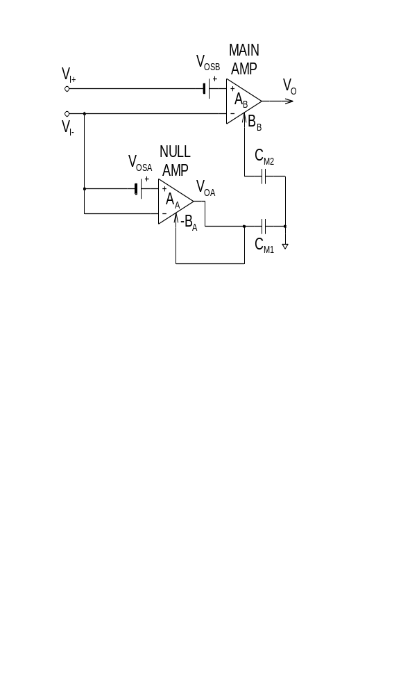 | 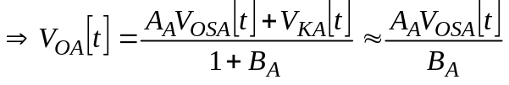

During the output phase (phase B-fig 4) the inputs of the nulling amplifier are connected to the input terminals. The nulling voltage of the nulling amplifier is now stored on capacitor C_{M1} and continues to minimize it’s output offset voltage. The instantaneous input signal is amplified by the nulling amplifier into the wideband amplifier through the wideband amplifier nulling terminal gain (B_{B}). The output voltage of the nulling amplifier is also impressed on storage capacitor C_{M2}. The total amplifier gain is approximately equal to the product of the nulling amplifier gain and the wideband amplifier gain. The total offset voltage is approximately equal to the sum of the nulling amplifier and wideband amplifier offset voltages divided by the gain of the wideband amplifier nulling terminal. By making this gain very large the total amplifier effective offset voltage becomes very small.

Fig 4-Phase B: Output Phase

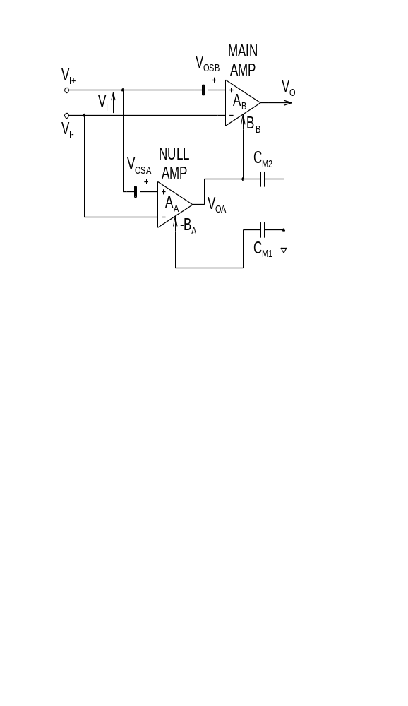 | 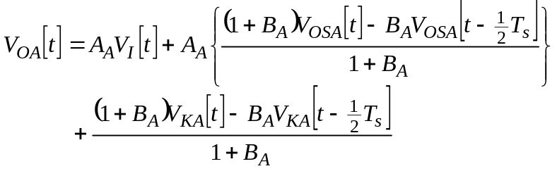  Both VOSA and VKA are high-pass filtered  "Corner frequency" of high-pass filter set by chopping frequency

If VOSA and VKA are time invariant then:
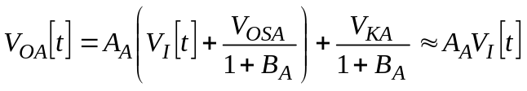

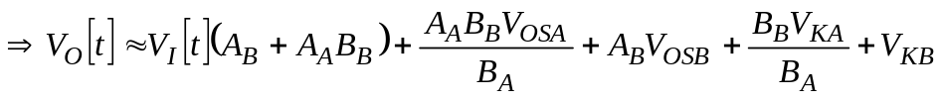


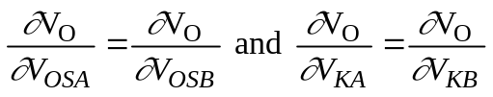

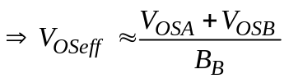

As the cycle returns to the nulling phase, the stored voltage on C_{M2} continues to effectively correct the DC offset of the composite amplifier. The cycle from nulling to output phase is repeated continuously at a rate set by the internal clock and logic circuits. This model circuit, while simplified from the actual design, accurately depicts the essentials of the auto-zero technique.

